Off-payroll rules

Client status determination statement

|  |
| --- |
| V3 March 2021  About this form p1  When and why to use this form? p2  The client's status determination status p2  Passing the SDS down the supply chain p2  Inside or Outside IR35? p3  Disagreeing with the client's status determination p4  How to use this form p4  Status determination statement p5 |

## About this form

The off-payroll rules have applied in the public sector since 6 April 2017. The rules will be extended into the private sector on **6 April 2021**. Clients who must comply with the rules, must determine the tax status of all engagements where services are provided by an individual working through an intermediary such as a personal services company (PSC).

Though the rules will not apply in the private sector until 6 April 2021, agencies, private sector clients and contractors will want to know the status of engagements before that date. This is so that they know their respective obligations and the pay and charge rates for the engagement. HMRC state that '

*"Status determinations made prior to 6 April 2021 can be a valid SDS for engagements carrying on after 6 April 2021, providing they meet the legislative requirements. A SDS must include the reason for reaching the conclusion and have been passed to the worker and any third party the client contracts with."*  ([ESM 10013](https://www.gov.uk/hmrc-internal-manuals/employment-status-manual/esm10013))

We originally released this template statement in February 2020 in anticipation of the changes which were scheduled to take effect on 6 April 2020. But in March the government delayed the changes until 2021. We now have the final legislation and so have updated this form. You can find more information on the off-payroll rules from the REC’s [IR35 hub](https://www.rec.uk.com/recruiters/legal/ir35).

Throughout the guidance notes we includes various hyperlinks, including HMRC's Employment Status Manual (ESM) - this is HMRC's internal guidance on employment status, including IR35. Whilst the ESM is not the law, it is useful to understand how HMRC will apply the rules.

## When and why use this form?

From 6 April 2021, the off-payroll rules will apply when:

* Supplying temporary workers who work through an intermediary such as a PSC [1], referred to as an ‘off-payroll worker’ in the rest of this document; and
* The client is (a) a public authority (already in effect since 6 April 2017) or, (b) a medium or large organisation or (c) not an overseas company.

Where the client is exempt it does not have to make a tax status decision and the employment business will not have to deduct tax and NICs before paying the PSC. Instead, the PSC must continue to apply the existing IR35 rules set out in Part 2, Chapter 8 Income Tax (Earnings and Pensions) Act 2003 (ITEPA).

**So, it is crucial that the employment business knows whether a client is exempt or not.**

You can ask a client to complete the [exempt client declaration form](https://www.rec.uk.com/recruiters/legal/template-documents/forms-and-letters/ir35-small-company-exemption-declaration) to confirm if it is exempt.

*Changes in a client's status* - If the client provides an SDS because it is a public authority, medium or large organisation, but later becomes exempt because its own status changes, the client must withdraw the SDS. The off-payroll rules will no longer apply and the intermediary, i.e. PSC, must apply the IR35 rules set out in Chapter 8 ITEPA. [2]

## The client's status determination statement

The off-payroll rules are set out in Part 2, Chapter 10 ITEPA. When the off-payroll rules apply the client must:

* decide whether the off-payroll rules apply to the engagement or not i.e. whether the engagement is 'inside IR35' or 'outside IR35' and
* provide a status determination statement (SDS) setting out its tax status decision and its reasons for the decision.

Passing the SDS down the supply chain

The client must pass its tax status decision, and the reasons for that decision, to both the party it has a contract with (usually the agency) and the off-payroll worker. Each party must pass the decision down the chain until it reaches the fee-payer i.e. the party next to the PSC in the supply chain.

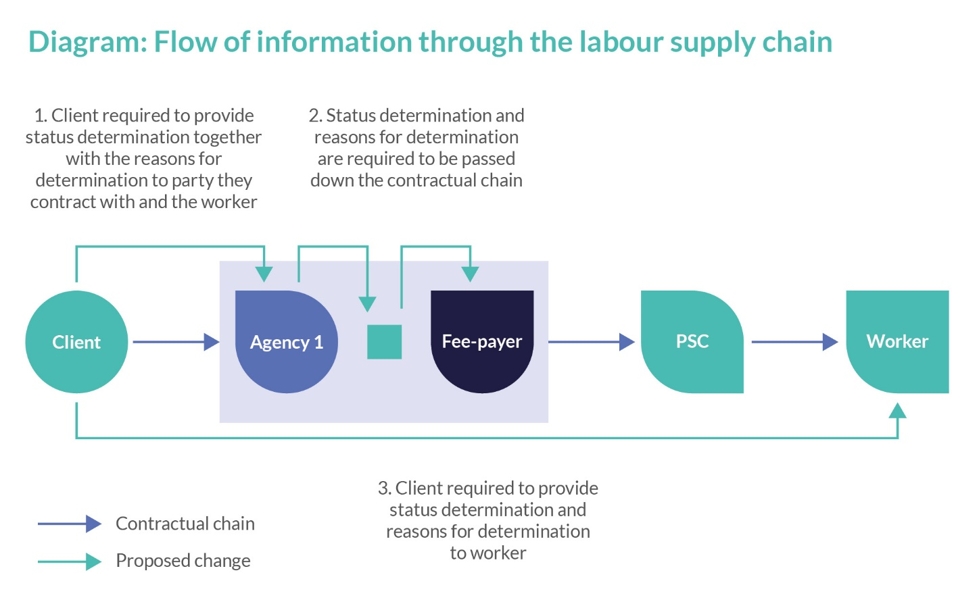Diagram adapted from the [government’s Summary of Responses](https://assets.publishing.service.gov.uk/government/uploads/system/uploads/attachment_data/file/817442/Off-payroll_working_rules_from_April_2020_summary_of_responses.pdf).

## Inside or outside IR35?

The IR35 rules are set out in Part 2, [Chapter 8 ITEPA](https://www.legislation.gov.uk/ukpga/2003/1/part/2/chapter/8) . The terms IR35, inside or outside IR35 are commonly used but are not defined in ITEPA. In brief, the rules apply to any off-payroll worker. IR35 should be assessed on an engagement by engagement basis and applied to a hypothetical contract directly between the off-payroll worker and the client i.e. one where the intermediary does not exist.

**'Inside IR35'** means the engagement is captured by the rules i.e. the off-payroll worker is deemed to be an employee (for tax purposes) of the client, meaning s/he should pay tax and national insurance in the same way as an employee. Employers’ national insurance is also due.

**'Outside IR35'** means the off-payroll worker does not look like an employee of the client, is genuinely self-employed (for tax purposes) and so employee tax and national insurance are not payable.

Note that office holder roles are always 'inside IR35' ([ESM 10001](https://www.gov.uk/hmrc-internal-manuals/employment-status-manual/esm10001)).

Under the off-payroll rules, the client’s status decision will determine the employment business’s payment and deduction obligations for the relevant assignment.

* If the client decides that the off-payroll rules apply to the engagement i.e. that the engagement is **'inside IR35'** then the party closest to the PSC becomes the fee-payer and must deduct tax and national insurance before paying the PSC (and pay employer’s national insurance). This should be reported via the fee-payer’s Real Time Information report.
* If the client decides that the off-payroll rules do not apply to the engagement i.e. that the engagement is **'outside IR35'**, then the party closest to the PSC is still the fee-payer, but it will not have to deduct tax or national insurance. Instead the fee-payer can pay the PSC gross and the PSC is responsible for its own tax affairs. The fee-payer (where it is an employment business) should report this payment via the [quarterly ITEPA reports](https://www.rec.uk.com/legal-resources/factsheets-and-guides/factsheets-and-guides/REC-Legal-guide-Employment-tax-issues-final.pdf)).

HMRC provide the [Check Employment Status for Tax Tool](https://www.gov.uk/guidance/check-employment-status-for-tax) (CEST) - see [ESM 11000](https://www.gov.uk/hmrc-internal-manuals/employment-status-manual/esm11000) for detailed guidance on CEST. The client can use any tool to make the tax status decision. The client can also use external support to come to their status decision but the client remains legally responsible for the decision.

**The client must take reasonable care** when making its tax status decision – otherwise it is not a valid SDS and the client becomes liable for any unpaid tax and national insurance. There is no specified format for the SDS, which is why we have created this template.

## Disagreeing with the client's status determination statement

The client is legally required to provide the status determination statement to the 'deemed employer' (usually this will be the employment business) and the off-payroll worker (where known) – it cannot pass this obligation to another party in the supply chain. The client must take reasonable care when making its IR35 status decision. For information on reasonable care see [ESM 10014](https://www.gov.uk/hmrc-internal-manuals/employment-status-manual/esm10014).

**Employment businesses/fee-payers should not make the IR35 status decision on behalf of the client or replace the client’s decision with their own view.** If the off-payroll worker or the employment business disagree with the client’s decision, they can request further information from the client which must then respond within 45 days of receipt of the enquiry. The client should then either:

1. confirm its status decision and give the reasons why; or
2. confirm that it has changed its decision, withdraw the original SDS and give a new SDS. [3]

**For more information on the SDS, reasonable care and disagreeing with the client's SDS see:**

* [ESM 10012 to 10014](https://www.gov.uk/hmrc-internal-manuals/employment-status-manual/esm10000)

## How to use this form

The REC produces template documents for its members to use. These are generic documents for use across a range of sectors so members will need to amend the documents to suit their own business needs. The REC legal team cannot amend documents for members, or review amendments they have made but can answer questions about understanding. However [REC legal business partners](https://www.rec.uk.com/index.php?&pageId=981&tag=Legal%20support) can assist members at discounted rates .

|  |
| --- |
| REC template documents have been prepared exclusively for REC Corporate Members. You must not distribute these template documents to third parties except where you require them to complete the document. |

[REC members can add their company logo if they wish]

## Off-payroll rules (IR35) status determination statement

|  |  |
| --- | --- |
| Client name: | [insert client name]  “the Client” |
| **Client registered company number:** |  |
| **Client registered address:** |  |
| **Client trading address (if different):** |  |
| **Name, role and contact details of Client contact:** |  |
| **Assignment to which this status determination statement relates** | |
| **Off-payroll worker’s name (where known):** |  |
| **Intermediary through which the off-payroll worker provides their services to the client via the employment business (if known):** | [insert details of personal service company or partnership the off-payroll worker will provide their services through - name and company no.] |
| **Assignment description “the Assignment”:** |  |
| **Date of status determination statement provided by the Client:** |  |

### Status determination decision:

The Client has determined that:

|  |  |
| --- | --- |
| The off-payroll rules do apply to the Assignment, i.e. the Assignment is 'Inside IR35' | □ |
| The off-payroll rules do not apply to the Assignment, i.e. the Assignment is 'Outside IR35' | □ |

Tick as appropriate.

### Reasons for the Client’s status determination decision:

The Client’s reasons for this status determination are:

|  |
| --- |
| [the Client must state how it came to this decision, e.g. Client could include a date stamped PDF of the results from CEST or another review tool or audit] |

The Client acknowledges that if it decides that this status determination decision is incorrect, the Client must withdraw this statement and provide another with immediate effect.

The Client also acknowledges that if the Client’s becomes exempt from Part 2 Chapter 10 ITEPA, the client must withdraw this status determination statement.

**The Client must satisfy itself as to when and how Part 2 Chapter 10 ITEPA applies to its own business and to any and all assignments.**

|  |  |
| --- | --- |
| **Signature:** |  |
| **Name:** | (Please print) |
| **Position at Client:** |  |
| **Date:** |  |

|  |  |
| --- | --- |
| Amendments to V2 (March 2021) | |
| We have updated the text to include the changes in the 2021 Finance Bill. | |
| **Amendments to V1 (February 2020)** | |
| Guidance notes | * We have expanded and updated the guidance notes. * We include hyperlinks to HMRC's Employment Status Manual. |
| Status determination statement | * We have added space for the client's contact and the date the client gives the status determination statement. |

1. IR35 or the off-payroll rules will only apply where the temporary worker has a material interest in the intermediary through which they work. An individual has a material interest when they(a) own, control or have beneficial interest in more than 5% of shares in a company or (b) are entitled to 60% or more of the profits of a partnership. But there will be a non-material interest provision for companies. The rules will apply if the contractor has 5 % or less of the company shares or they receive, expect, or entitled to receive payment that is not deemed employment income. Typically, temporary workers working through an umbrella company or a CIS intermediary (as a sole trader) will not have a material or non-material interest in the umbrella or CIS Intermediary and therefore IR35 cannot apply. However, if someone works through their own company or partnership, they will have a material or non-material interest. You must confirm shareholdings/partner share to understand whether a temporary worker has a material or non-material interest in the intermediary or not, and therefore which tax rules apply.

   For ease, we use the term PSC in this document to include both personal service companies and partnerships.
2. Section 61TA ITEPA
3. The client led disagreement process is set out at section 61T ITEPA. The requirement for clients to have a disagreement process only applies from 6 April 2021 so public authorities do not currently have to have such a process.