House of Lords Science and Technology Committee call for evidence - "people and skills in UK science, technology, engineering and mathematics"

A response from the Recruitment & Employment Confederation (REC)
September 2022

About the REC

The Recruitment & Employment Confederation (REC) is the professional body for the recruitment industry. We represent 3,000 businesses who help more than a million people find a new permanent job each year, and on any given day place nearly 1 million onto a temporary, contract or freelance assignment. We drive standards and empower recruitment businesses to build better futures for jobseekers and businesses, and we do this by providing legal advice, business support, training and labour market intelligence.

The REC is committed to working with the government to find workable solutions to current labour marketing challenges, not least ongoing labour and skills shortages. Our members give us valuable insight into what’s happening in the labour market, as well as an understanding of the impact government policy has if implemented.

The data we share in this written response comes from several of our data sources, including:
- REC's Jobs Outlook – our monthly survey of employers on their hiring intentions, conducted in partnership with Savanta ComRes
- REC & KPMG's Report on Jobs – our monthly survey of recruiters on hiring activity in the month just gone, making this the earliest lead indicator on UK job market performance. This has been completed by S&P Global (formerly IHS Markit) on behalf of the REC for 25 years.
- REC’s Labour Market Tracker - analyses job posting and vacancy data with labour market intelligence experts Lightcast (formerly Emsi-Burning Glass).

Summary

Over the past two years, labour and skills shortages have dominated headlines and been felt by businesses across the country. The STEM sector has not been immune, with growing gaps in some of our most important growth sectors, like digital technology, cyber security, and software development.

A recent report by the Recruitment & Employment Confederation (REC), Overcoming Shortages: how to create a sustainable labour market, shows the economic impact of not addressing labour shortages could see UK GDP fall by up to £39 billion every year from 2024.

While the pandemic has thrown the situation into sharp focus, labour and skills shortages have been with us for years. Latest REC data shows:
- Ongoing skills shortages, a reduced supply of foreign workers and greater hesitancy among some people to apply for new roles has resulted in a marked drop in total candidate supply.
- The ongoing imbalance between the supply and demand for workers and the cost-of-living crisis has driven further increases in starting pay.
- Demand shows no signs of slowing down. In the last week of August 2022, there were 2.08 million job adverts in the UK, a new record high for 2022.

Our national challenge is that there are over half a million fewer people in the labour market than before the pandemic. Solving this participation problem is essential for economic recovery and growth. We know that workers are the most important asset for business - they help drive their success and contribute to the success of our economy. To create a sustainable labour market and stoke economic growth, we need to put people first.

Much of this challenge lies with business to address – from getting offers of employment right to investing in skills training. If businesses say people are their most important asset, they need to act that way. But we also need an environment that helps businesses make the changes needed. For example, by working with partners in colleges, local areas and government to support young people starting careers in STEM.

For government, a long-term labour market and workforce strategy is vital. We need to provide a vision for the future, a direction of travel and a plan for achieving it. Skills is part of that, but not the only part – immigration, devolution, and labour market activation all matter.

We have answered questions from the Committee where we can share data and insights.

REC data demonstrates the scale of the challenge

Labour and skills shortages are affecting every sector, in every part of the UK. The REC first flagged a return to strength for the labour market last April - based on the day-to-day insights our recruiter members were seeing. Today, labour and skills shortages remain one of the biggest concerns for recruiters and their client businesses.

While there are fewer unemployed people in the UK, employment levels and hours worked are still lower than pre-pandemic levels. This is because of rising economic inactivity, with more people not working and not seeking employment. Over time, this capacity constraint will slow growth and contribute to inflation.

In 2021, we saw record-breaking recruitment figures - a trend that our lead indicator data shows is beginning to level off. A slowdown from those record-breaking highs is by no means an indicator that labour and skills shortages are over. For example, the REC’s latest Labour Market Tracker showed that in the last week of August, there were 2.08 million job adverts in the UK, a new record high for 2022.

Careers in the STEM sector aren't immune to the ongoing battle for talent despite being one of our biggest sectors for growth potential. Insights from REC members suggest that we're not doing enough to attract talent in this area, instead losing out to more competitive countries like the US. Part of this comes down to salary, part of it is because of our immigration system, and another factor is the move to more flexible working. For example, one of our members, recruiting in cyber sector, told us that a few years ago, roughly 80% of their cyber recruitment was UK based, 10% was US based, and 10% EU based. In 2022, 85% of their hires are US based, 10% are in the UK, and 5% are in the EU. Overall, the skills gap for STEM careers in the UK is growing.

One of the most concerning gaps is in cyber. We live in an increasingly digital world. Our critical resources - public services, healthcare, energy, and transportation - are all online. And threat actors know this. According to the 2021 (ISC)² Cybersecurity Workforce Study, the global cybersecurity workforce needs to grow 65% to effectively defend organisations’ critical assets.

Software development and software engineering skills also feature heavily in job adverts. Unsurprisingly, REC data shows that programming skills (SQL, Python, Javascript etc.) are in increasingly high demand. For example, out of the 2.4 million jobs within the STEM field advertised between June and July 2022, just over 45,000 mentioned software development skills. In the same period, more than 76,000 jobs mentioned SQL programming language. The numbers tally with insights from our members too. One member recruiting in the sector spoke about the shortage of software engineers and developers, saying "they’re just not around anymore. Supply just isn’t keeping up with demand.”

Government needs an immigration and skills for growth policy

Although we need to develop talent and skills strategies for our domestic workforce, we simply don’t have enough STEM graduates in the UK right now. Until we get our strategies for homegrown talent right, we need to look overseas for talent. We spoke to several REC members recruiting in technology, engineering and the life sciences sectors and the overwhelming feedback was that our immigration system isn’t working for STEM. Some of our members are actively moving away from recruiting for certain sectors like software recruitment because of the difficulties finding homegrown talent with the right skills. One REC member told us that we're "tying one hand behind our backs" with the current immigration system.

Another member recruiting in the engineering sector is already taking on more international work because opportunities at home are much more limited. He told us that in just one week in August, of the nine contractors he placed, seven were based outside the UK. Part of this is down to the cost and difficulty of navigating the new immigration system. In his view, "the UK is still an attractive proposition for people working in the STEM sector, but until we address the barriers to entry, it's going to be too difficult for many to access."

What we hear most often from employers is that the cost and long timeframe puts them off investing in the current visa system. An REC member recruiting in the life sciences sector explained that pre-Brexit, around 5-10% of entry-level positions were filled by candidates from Europe. However, because of the cost and timescale associated with visas, UK companies have become more reluctant to fill roles using European workers. In STEM, the often-technical nature of the work means training for entry-level roles can take significantly longer (six to 12 months) than training in other roles. This means that if an employer has invested in a two-year work visa, by the time someone is fully trained – they may only have six months left to be eligible for work under the current visa system, which is just too short a time. For many, the costs outweigh the benefits.

In addition, many STEM projects tend to last beyond just two years. We're seeing a growing number of digital transformation projects across the UK, and these can last from anything between two and three years, meaning candidates on two-year visas would be unlikely to participate in the full project, from inception to completion. This disjointed approach creates a problem for both employer and employee, with someone having to be brought in and trained up after a project has already started, or training someone to take over a project three-quarters of the way through. This results in more cost and resource for the business and could impact overall delivery.

While the government should develop home-grown talent strategies, we need an 'immigration for growth' policy approach. According to REC research, immigration is amongst the top priority policy areas being used by other G7 countries like Canada and Germany to alleviate labour and skills shortages. Immigration should be part of the solution to put the UK in a strong, globally competitive position.

- That's why the REC is calling for an extension to work visas from two years to at least five. It's a straight-forward step that would make employers more likely to invest in global talent and see a return on that investment.

Employers need to get their offer right

According to Department for Digital, Culture, Media & Sport (DMCS), gross value added (GVA) by the digital sector in 2021 was £138 billion. The Department's annual estimates showed that, up to 2019, GVA by the digital sector grew faster than GVA by rest of the UK economy, increasing by 27% in real terms between 2010 and 2019 compared to 17% for the UK economy. This shows how much growth potential this sector has but skills shortages and labour constraints are hampering our ability to realise that potential.

We know part of this comes down to getting our immigration system right, but there's also a role for employers to play. For some time, the US has been one of our biggest competitors for STEM, but the rise of remote working has seen that gap widen. Of course, it's something that works both ways, with UK candidates choosing to work elsewhere while living here, and candidates from outside the UK working for UK-based companies while living abroad, is a trend we’re especially seeing in IT/digital roles.
That's why it's more important than ever for employers to get their attraction offers right.

For years, we've struggled to compete with US companies, with some offering salaries that are more than double their UK equivalents. Simply increasing UK salaries isn't necessarily viable. According to our Report on Jobs, data, starting salaries have already increased across most sectors as employers fight to attract staff in this tight labour market. It’s important to recognise however that for those not moving jobs, ‘real pay’ hasn’t gone up. In addition, for those companies that can afford it, the offer and counter offer is on the rise. While salaries in some STEM sectors are on the up, particularly in engineering, pharmaceuticals, and biotechnology, higher wages are only sustainable if we've got the productivity to match, something the UK has long lagged behind G7 counterparts.

For some companies that simply can’t afford to increase wages any further, finding other ways to attract and retain staff is key. Aside from better employment protections, rights, and benefits like higher annual leave already offered in the UK, compared to the US, employers can offer better benefits packages. Recruiters tell us that factors including flexible working, enhanced maternity/paternity packages, and better pensions, can be just as important (if not even more important) to many candidates in today's job market. We can't overemphasize the value of good working conditions - now, more than ever, candidates want (and expect) to have a great place to work.

Government, business and education providers need to collaborate

Although a lot of work has been done to promote STEM careers in schools, there is more to do. Our recent report, Overcoming Shortages: how to create a sustainable labour market, highlighted the desire from businesses to see greater collaboration between government, business and education providers at local level to provide better careers advice. One of our report recommendations is for government to build on the success of the Gatsby Benchmarks to ensure every young person gets effective, locally relevant careers advice. Currently, the quality of careers advice is more of a postcode lottery, something we must address if we're truly going to realise levelling up ambitions.

We know the majority of people in the UK live and work within 20 miles of where they grow up, and the numbers are even higher for those aged 18-24. Local businesses and local people are the experts when it comes to their areas – this includes recruiters. They are the ones who understand what training and skills are needed to meet local employment demands. If they team up with schools and colleges, there is more chance of relevant training provision to suit local needs. Often the information recruiters have is far more granular and relevant than what schools and colleges have. With this partnership approach, we can unlock the vast economic and levelling up potential of these areas.

Breaking into the jobs market can be difficult for any new graduate, but for many STEM roles, it is even harder. Some STEM roles are highly technical and ‘entry-level’ jobs generally require a master’s degree along with at least 12-18 months of experience. The sheer cost of undergraduate and postgraduate courses can be a barrier to entry. For others, getting the relevant experience needed, while studying, simply isn't possible. This makes it even harder to fill 'graduate' roles, resulting in growing gaps in the workforce, and a dismayed group of jobseekers desperately trying to enter the labour market. However, there are practical steps we can take to address this.

- More universities and higher education providers should partner with local businesses to provide one year of practical experience for those on eligible STEM courses.

Not only will this give students the experience they require, but it will build relationships with local businesses, providing opportunities for graduate schemes or future jobs upon graduation. Importantly, this sort of placement will help students transition from university, better preparing them for the world of work.

- To improve accessibility, the government should introduce a bursary system to help with the cost of living and study for students on eligible STEM courses, for example, those undertaking courses in cyber security, computer science, software development etc.

We need to rethink 'STEM'

The other reason we need to see greater collaboration between government, business and education providers, is to fully explain what STEM careers actually look like. Many of our members recruiting in that sector feel there's still a lack of understanding about just how diverse STEM careers can be - it's not just lab coats and engineering, there's a plethora of career options, from quality control, comms, marketing, digital strategy, business development, and customer support - this list goes on. Unfortunately, the existing perception of STEM can result in a lack of diversity within the workforce, something we must address if we are truly going to tackle labour and skills shortages.

We already know that companies with diverse workforces are more successful than those that aren't. That's because diversity in teams allows for better innovation and a wider range of ideas and experiences to be called on. EDI practices can increase recruitment and retention rates, something which is increasingly important in this tight labour market. By increasing recruitment pools to include a diverse range of candidates, businesses will widen their talent pool. Inclusive practices in the workplace can also help retain staff, while non-inclusive business practices can alienate staff, increasing the likelihood of leavers.

The REC members we spoke felt the term 'STEM' was a bit dated, misunderstood, and doesn't go far enough to explain just how diverse the sector, and roles within STEM sectors, are.

- Rather than using the phrase STEM, which lumps a multitude of careers together, government, businesses and education providers should talk about the different career routes that make up STEM. This will better explain the options that people have and tackle some of the pre-determined views of what STEM is and who can work in it.

Latest REC data

The tables below show the STEM skills and STEM occupations in demand in July 2022.
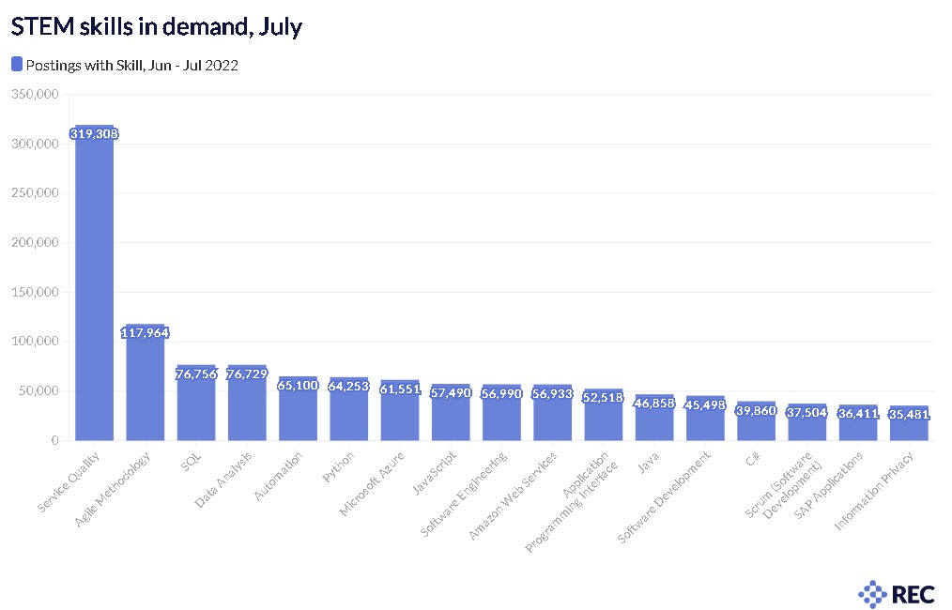


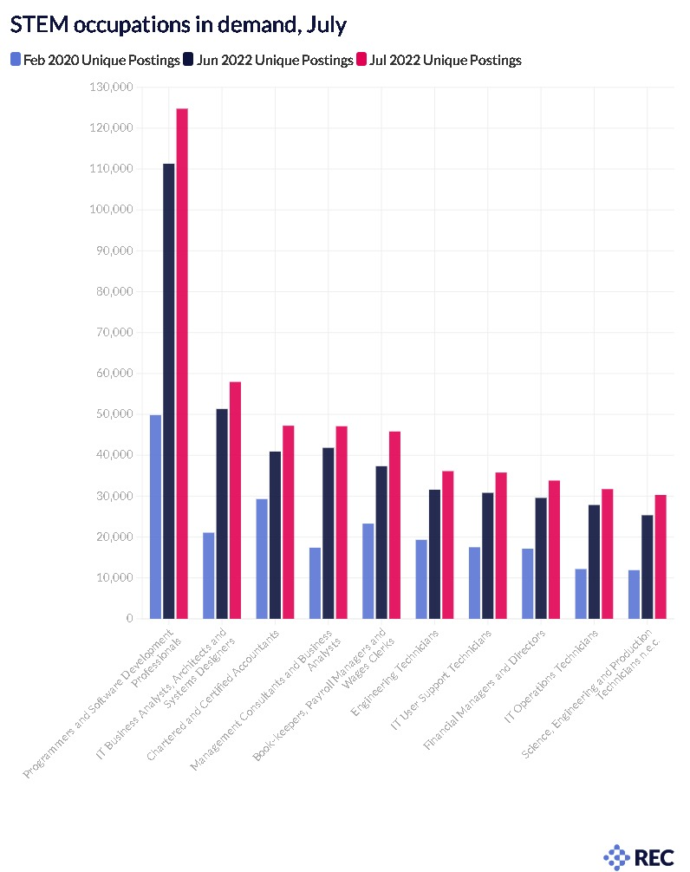

The table below shows the increase in salary for permanent and temporary workers since July 2019.

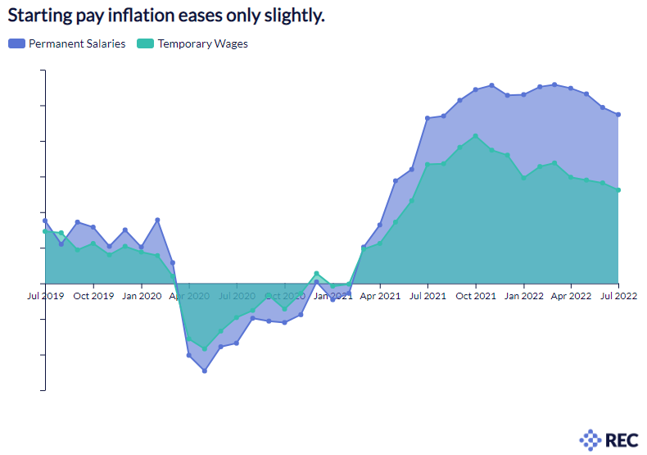

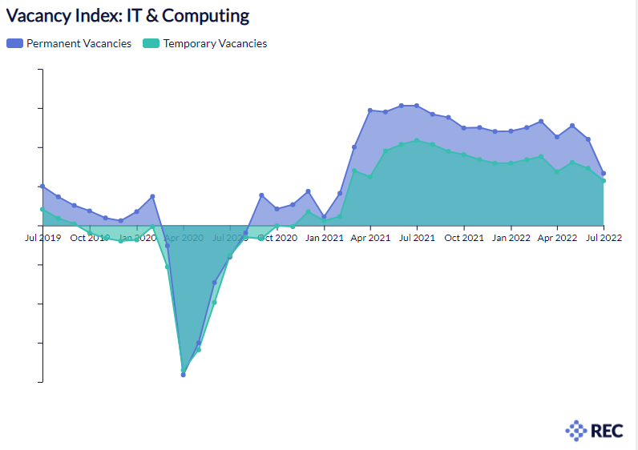
Numbers of vacancies in IT and Computing

Numbers of vacancies in Engineering
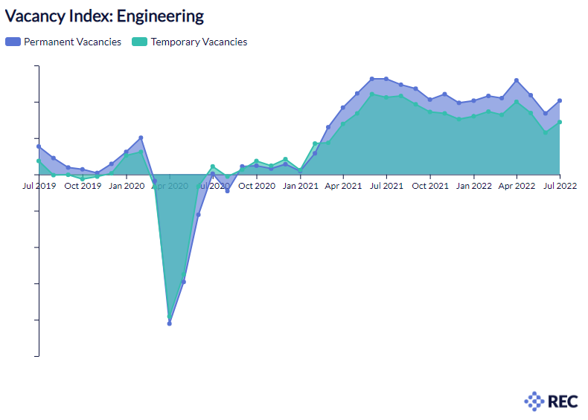

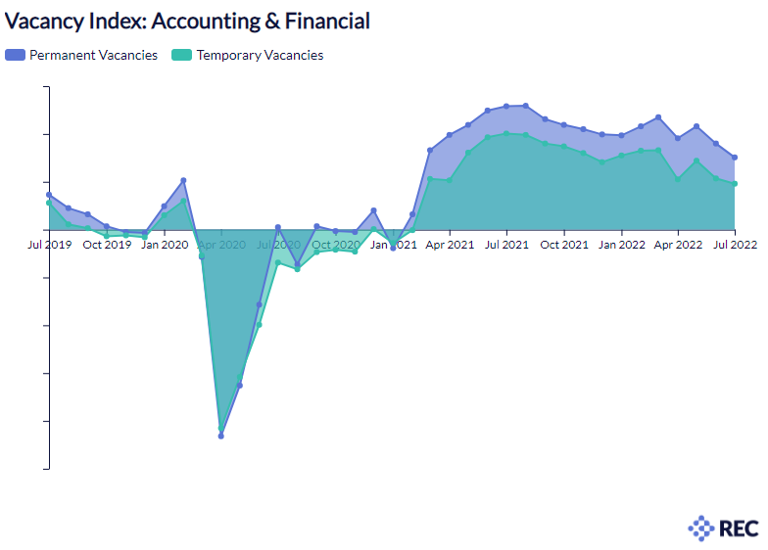
Numbers of vacancies in Accounting and Financial

For more information on this submission, please contact:
Samantha Beggs, Campaigns and Government Relations Manager, REC, sam.beggs@rec.uk.com


(ISC)2, A Resilient Cybersecurity Profession Charts the Path Forward: Cybersecurity Workforce Study, 2021
Recruitment and Employment Confederation, Overcoming Shortages: how to create a sustainable labour market, July 2022

