The Rt. Hon. Rishi Sunak MP

Chancellor of the Exchequer

HM Treasury

1 Horse Guards Road

London, SW1A 2HQ

09 March 2022

Dear Chancellor,

As restrictions begin to lift and we embrace the new normal, business confidence is returning, but significant challenges still lie ahead: inflation, candidate availability and skills shortages, and plugging the productivity gap. The Spring Budget is an opportunity to build on the success of the vaccination programme and lay the groundwork for future prosperity by investing in the key driver of economic recovery and success – our people.

Ahead of Spring Budget, I am writing to you to share our analysis of the labour market to help inform policy development in HM Treasury. Based on that analysis, we have set out a small number of recommendations, which we believe will help government get the best return on investment.

The strength and resilience of the UK jobs market remains remarkable by any historic comparison, as vacancies rise and unemployment falls. As we saw throughout 2021, temporary and part-time work continues to play a huge role in our recovery as more people look for flexibility in uncertain times - but also, increasingly, as a lifestyle choice.

The REC is concerned by the high level of economic inactivity in the labour market, particularly among older workers. According to our [Labour Market Tracker](https://www.rec.uk.com/our-view/news/press-releases/labour-market-tracker-increase-job-adverts-every-type-role-across-uk-last-week), the number of job adverts in the UK has been steadily growing since the beginning of 2022, as the Omicron wave receded and hiring activity increased. Employers’ confidence levels have also been boosted by the easing of Covid-19 restrictions. However, the high level of job adverts also reflects the difficulty firms are having in hiring.

The UK economy is facing severe capacity constraints as it recovers, which is contributing to higher inflation. We fully support your aim to build ‘a stronger economy of the future’ but in order to do so we ask you to address the following in your spring Budget.

On behalf of our members, we are asking you to:

1. **Delay the National Insurance rise -** this is the wrong type of tax. Businesses and individuals are trying to recover from the impacts of the pandemic, whilst also trying to respond to rising inflation, and manage in a candidate-driven market, increasing labour taxes is simply not a fair or effective way of supporting our health service.
2. **Reform and enhance the Apprenticeship Levy** - use of a reformed levy to fund high quality, Ofqual regulated training of different forms would enable the levy to work more effectively, change lives and enhance the apprenticeship brand by returning it to its purpose, rather than making it the answer to every skills issue.
3. **Ensure workforce planning is front and centre** – by establishing a cross-departmental forum, working in conjunction with business and industry to consider long-term workforce planning, identifying potential skills gaps, and introducing the right policies to boost productivity and labour market engagement. In order for this to be successful, the forum should include industry experts, like the REC and its members who see and understand labour market skills needs.
4. **Ensure we have a fair and flexible immigration system -** we support the need to train, attract, upskill, and retain domestic talent. However, we also recognise that immigration also plays a role in supporting the UK's labour market with skills and talent not accessible from within the UK. We must have a system that can quickly and effectively respond to the needs and demands of our labour market. Reviewing the Shortage Occupation List (SOL) on an annual basis would position us to better respond to changing needs. Creating a cross-departmental forum, working with industry, would also help to create a regular 'channel' where labour market experts provide up to date insights and recommendations about what sectors and roles are likely to experience shortages - keeping the SOL up to date.

## National Insurance increase

It’s vital that the social care system is properly funded However, the 1.25 percentage point rise in National Insurance, the UK’s biggest business tax, is the wrong choice at the wrong time. Business margins are tight for our industry as they try to recover from the impacts of the pandemic, while at the same time, fighting rising bills and increasing inflation.

As a tax on jobs, and a tax on activity rather than profits, rising National Insurance will fall more heavily on the labour-intensive sectors most affected by the pandemic. The increase will also disproportionately affect lower earners. The accompanying rise in taxes on dividends will also hit small, limited company directors, who were denied any support during the pandemic. In addition, a National Insurance increase will detract from business investment and hit household incomes at a time when inflation is already high and events on the world stage risk that rocketing further. Of course, social care needs more funding but increasing labour taxes as we try to recover from the pandemic is not the fairest way to do it.

## A skills revolution must enable employers to invest

Skills shortages remain one of the biggest concerns for our members, both within their own businesses and in sourcing candidates for their clients. Many recruiters are reskilling and upskilling existing staff, others have set up training academies to help school leavers and graduates develop their skills - something which more businesses will need to do if we are to achieve our ambitions of a ‘high skill, high wage’ economy. While there are things that industry can and must do, government can do so much more even with existing funding by targeting it in a way that supports real time and future needs of industry. A joined-up approach between business and government is the only route to drive the skills revolution we need in the UK.

Local skills plans which harness national qualification standards, improve social mobility, and boost local and regional competitiveness are an important part of the levelling up agenda and a step in the right direction. But we must ensure they are effective, have access to the latest data (we can help with that), and are genuinely benefitting the area for which they are responsible. Developing a long-term strategy, which joins up our education and skills system with local employers would help ensure parity across regions and provide a ground level mechanism for skills and workforce planning to better meet the needs of local economies. Scaled up, that insight could build a workforce plan at a more strategic level for the longer term.

Skills Bootcamps have been a successful initiative for some of our members, but we'd like to see their remit expanded, ensuring they can best respond to labour market needs by being adapted to meet a broader range of skills levels and a more flexible approach to completing training.

## An Apprenticeship Levy that works for all

One of the trends we saw last year was that many of the hardest-to-fill vacancies are for roles requiring level one and level two skills - often overlooked by the current funding which focuses on level three and above qualifications. This mismatch can be remedied without much increased Treasury investment by making the Apprenticeship Levy more flexible and easier to access by part time and agency contractors.

Temporary agency workers are often unable to access apprenticeship schemes because of the strict requirements around how an apprenticeship is structured, in particular the fact that apprenticeships need to last for a minimum of 12 months. According to [research by the REC](https://www.rec.uk.com/our-view/insights/government-and-campaigns/training-temps-grounded-research), only 2% of temporary assignments last for 12 months or more. This means that of the almost 1 million temporary workers working on any given day, approximately 960,000 are automatically cut off from apprenticeship opportunities, despite having their wages levied to pay for training for other workers. We do not want to see a change to apprenticeships – as they are a gold standard in training – but we think the levy funding not being used for apprenticeships could be put to use to support in-work progression.

Examples of courses REC members have specifically highlighted as ones they would like to be able to use levy funding on include:

* Forklift truck driving
* Health care assistant training
* Manufacturing and production management
* Health and safety awareness
* Mental health awareness
* Manual handling
* Leadership/management training
* Advanced IT skills

The REC has called for the levy to be broadened before, but the impact of reform of the levy in the current labour market could be higher than ever before - helping to fill vacancies quickly by equipping people with the right skills. For the recruitment industry, the Apprenticeship Levy has been a disproportionate tax, which they have not been able to get a fair return on.

Research from our levy report found that 670 REC levy paying members had £104 million of unspent Apprenticeship Levy funds between them - which cannot be used to support the temporary workers on their payrolls. A more accessible route to using levy money would be a valuable tool in the government’s levelling up agenda and improve social mobility.

Lack of access to training is the biggest barrier to preventing workers progressing their careers and increasing their earnings potential.

## A fair and open immigration system

We have been harrowed, outraged and saddened by the Russian invasion of Ukraine. We have a proud history of supporting those in need, one that normally extends beyond the humanitarian effort - providing sanctuary, giving people a safe place to sleep and work is absolutely critical.

The REC is proud to be a member of the Lift the Ban campaign, which calls on government to give refugees the right to work while they await a decision on their claim. The need to rethink this policy, matters more than ever. We recognise the benefits the refugees we are expecting from Ukraine and places such as Afghanistan can bring. Being able to work is a fantastic way of helping refugees feel welcome, integrate into UK society, and contribute to the success of our economy. Work improves asylum seekers’ mental health, helps integration, supports language learning, and means people are not left struggling to find employment when their asylum claim is accepted. There are also significant economic benefits to be gained - according to Refugee Action, lifting the ban would provide an additional £180.8 million for the Treasury every year. Not only is it the right thing to do, but it makes business sense too.

We want to see an immigration system that is fair, flexible, and open - if we are truly to grasp the opportunities of Global Britain, post-Brexit, then we should recognise the value of immigration, and not shy away from it. Getting our immigration system right is important but offering safe passage to those fleeing conflict, providing a place to stay and opportunities to work, could be lifesaving.

In addition to the asks above, we would like government to:

## Invest in activation programmes and work finding services

Activation programmes, like Kickstart and Restart, are an excellent way of getting those furthest from the labour market engaged. The REC was delighted to be a Kickstart Gateway organisation for a programme delivering employability skills that will last young people a lifetime. Our main piece of feedback is that administrative challenges prevented Kickstart from reaching more young people. Some analysis has shown roles had only a 15% fill rate – there was no shortage of employers offering placements, but we lacked a structured comms and outreach programme to young people. We'd be keen to work alongside government to help improve the efficiency of these programmes for the taxpayer, as well as their effectiveness for participants.

Similarly, we recognise the value and importance of working with JobCentre Plus and we fully support the government's ambitions regarding older workers, disabled workers, and engaging those furthest from the labour market. Our recently renewed Partnership Agreement with DWP supports these shared ambitions. As you know, our members are experts in the labour market, and they want to collaborate with public employment services to support all those in their community who are seeking employment. Matching people to roles in a labour market with such high vacancy rates makes it even more important for recruiters and job centres to work together.

Recruitment agencies can deliver targeted employment support to claimants, reducing the burden on the JobCentre Plus to deliver both employment and financial support. There is also strong evidence to suggest that partnership working between the recruitment industry and Jobcentre Plus can help minimise unemployment in times of economic recovery, for example after the 2008-09 financial crash. More recently, this partnership approach was used to help Thomas Cook workers into new roles, following the company's liquidation.

## Fostering business investment will deliver for Government

Work by the CBI, Be the Business and others has shown that UK dissemination of key technology is slower than in competitor economies, hampering firms’ ability to be productive. Embracing technology and innovation is as important as research and development, and that must be factored into long-term thinking. The Government's ‘Help to Grow: Digital Scheme’ is an excellent example of this. More schemes like this will help the UK take the lead in the digital revolution and will play an important role as we seek to level up. ‘Help to Grow: Mentoring’ has the potential to do this too, if well delivered.

Our members frequently talk to us about business tax rates, particularly when inflation is high and other parts of their cost-base are under pressure. Although last year’s Budget provided some welcome support in this area, namely business rates relief for retail, leisure and hospitality businesses in England, we need a more permanent solution to make the system fairer and support local economies. We are very keen to see the business rates system help to achieve net zero – for example, providing a financial incentive or freezing business rates for a period of time when a business makes an investment to improve its carbon footprint. The importance of sustainability and robust ESG policies are important to the future workforce. Last year's [Future of Work report](https://rec365-my.sharepoint.com/personal/sam_beggs_rec_uk_com/Documents/Green/•%09https:/princestrustinternational.org/new-princes-trust-research-on-how-young-people-view-the-future-of-work/) from the Prince's Trust found that 77% of young people would consider the environmental impact of the company or sector when choosing a job.

I hope this is useful as your department prepares for the Spring Budget, but if you need any further information, don't hesitate to get in touch. As always, the REC stands ready to help.

Yours sincerely,



**Kate Shoesmith**

**Deputy Chief Executive**

# Latest Research from the REC

Below is an overview of our current UK labour market. It is this data that informs our recommendations in this submission. Our data is processed at a quicker pace than most official data, normally within two weeks of closing fieldwork, thus providing up-to-date insights on labour market conditions. As such, REC data is often used by the Bank of England and the Office for National Statistics, amongst others, as a leading indicator in their analysis and projections. We share this information to support HMT in your analysis ahead of the Spring Statement and would welcome the opportunity to provide you with further evidence ahead of future fiscal events.

## REC's Jobs Outlook, February 2022

As the Omicron wave receded in January, business confidence levels started to show signs of recovery. In November 2021-January 2022, business confidence in the UK economy rose by six percentage points from the previous rolling quarter to net: -5. In January, employers’ confidence levels turned positive (net: +1). This suggests more positive expectations for the economy in 2022, despite the threat of rising inflation and labour shortages.

The REC’s latest JobsOutlook survey also found that employers’ confidence in making hiring and investment decisions rose to net: +17 in the three months to January. This was eight percentage points higher than the previous rolling quarter.

With somewhat improved confidence levels, employers’ intentions to hire permanent staff increased further. Hiring intentions in the short term increased by four percentage points to net: +24, and medium-term demand rose by five points to net: +24.

However, hiring intentions remained highest for temporary workers in the short term, at net: +28. Temps will play a vital role in keeping businesses going as they adjust to the new normal. The role of temporary work in providing incomes and flexibility as we deal with cost-of-living increases should not be underestimated. Employers need more staff and temporary work can offer the increased income people need while maintaining other commitments such a family or caring responsibilities

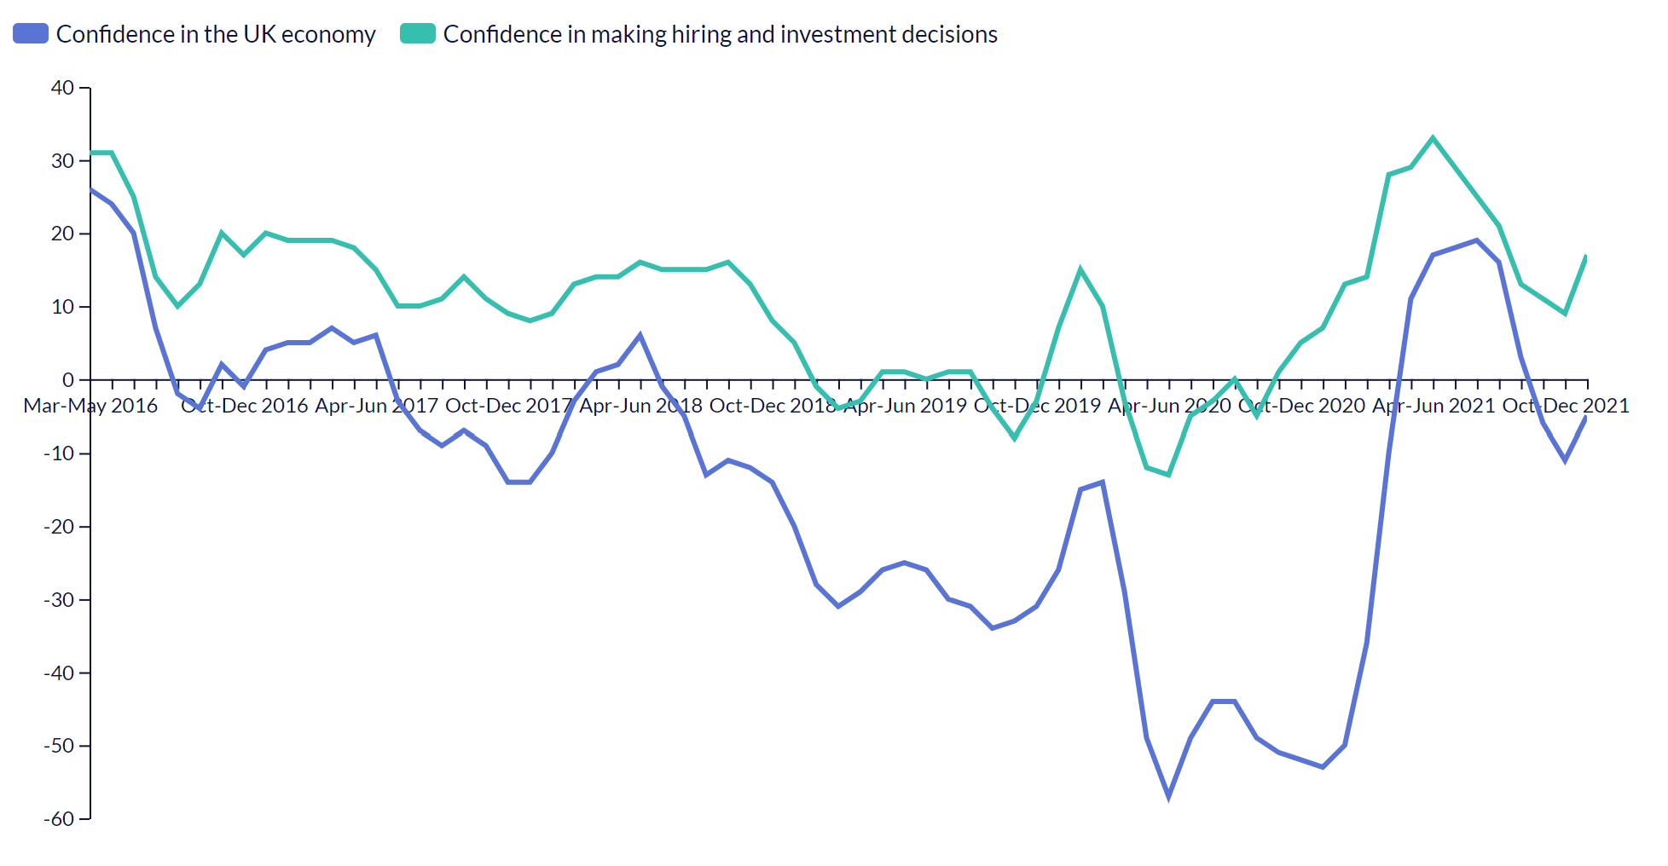

Other stats from the latest JobsOutlook include:

* Hiring intentions for temporary workers in the medium term remained robust at net: +19.
* In January, three in ten (31%) employers reported that candidates they have interviewed since the pandemic began in March 2020 preferred some form of hybrid working. Just 13% would rather work exclusively from home. The strongest preference was to be predominantly at business premises with some remote/home working (17%).

## REC's Labour Market Tracker, March 2022

The number of job adverts in the UK has been steadily growing since the beginning of 2022, as the Omicron wave receded and hiring activity ramped up. According to the Recruitment & Employment Confederation (REC)’s new Labour Market Tracker, there were 224,000 new adverts posted in the week of 21-27 February – the highest weekly figure since early December.

As a result, the total number of active job postings has continued to rise through January and February, following the normal seasonal drop in late December. Last week there were roughly 1.82 million job adverts live in the UK, 8.6% higher than in the previous week.

The number of active job adverts grew in every occupation in the UK in late February. The most significant rise was for fitness instructors (+23.6%). But there were also significant rises for furniture makers and craft woodworkers (+20.9%), as well as tailors and dressmakers (+15.5%) – perhaps as the leisure and entertainment industry begins to kick back into gear.

The gradual return to offices and other workplaces could also be increasing demand for some roles. Childminders saw an increase in demand of 16.8% from the previous week, while adverts for mobile salespeople with rounds, including those selling food and drink to office workers, increased by 23% week-on-week.

In addition, every local area in the UK except for three recorded at least a marginal increase in active job postings last week.

