REC Level 5 Diploma in Recruitment Leadership
RECTC 5-5 Client and Stakeholder Relationship Management

Past Exam Paper

Time allowed: 90 minutes
70 marks

- Students are required to answer all questions
- Marks allocated to each unit and question are clearly shown
- Where appropriate bullet points can be accepted
- Do not penalise students for grammatical/spelling errors
- Annotate the MS where additional, relevant answers are given by students
- Mark in red ink
- Ring totals for each of the questions and transfer to front cover
- Indicate you have seen each and every page by marking in red ink
- Do not add personal comments about student performance
- Alert REC to any suspicion of collusion, dyslexia or other problems
- Keep an independent record of student marks in case of mislaid scripts
- Alert REC to any comments, notes etc., in script from student

- Billy is a Recruitment Director for an I.T. recruitment firm, In Touch I.T., based in London. In Touch provides services to clients across the UK. Billy manages the permanent side of the business, reporting directly to the owner, Cheryl. His colleague, Nina, manages the temporary side of the business. Cheryl is relatively hands-off, but does meet with Billy and Nina once a month, for a performance update.

One of their clients, ‘Hercules Investment Management’, has asked Billy to submit a response to a tender to manage all their I.T. recruitment. Both Billy and Nina have worked with Hercules for some time and know their internal I.T. recruitment contact, Lucy Porter, very well. Lucy has recommended Billy to her manager, Paola, who has sent him the initial R.F.I.

Billy has a meeting with Lucy, to try to find out as much information about the tender as possible. Lucy tells him that Paola manages the recruitment budget and, although Lucy will ultimately be his internal contact, Paola will manage the tender process, having the final say on which agency they choose to appoint. Whilst she knows Nina manages the temporary recruitment, they only want one point of contact and Lucy has suggested that Billy is the better person for the role. He will need to complete a large tender document and present this information to Paola and their C.I.O, Marco. Marco will not be involved with recruitment on a day-to-day basis, but will have the final say on all permanent candidate hires.

- Billy decides to complete a stakeholder analysis of all parties involved.

What are the benefits to Billy of using a stakeholder management approach?
(4 marks)

Award up to 2 marks for two of the following to a total of four marks:

A Opinions of powerful clients and stakeholders can shape a project in its early stages. Appropriately engaging with stakeholders will mean that it is likely that these individuals will offer their continued support of the project and may offer suggestions as to how it can be improved (2 marks)

B Opening the lines of communication with clients and stakeholders at an early stage ensures that they have clarity of the end goal and that they understand the benefits, or why an action takes place. Again, they can actively support when necessary (2 marks)

C By testing an idea on a group and conducting a consultation, a reaction to the project or message can be gauged. This reaction can be built in to strategic decision making, to win further stakeholder support and avoid potential problems arising in the future (2 marks)

- Using a Power/Interest grid Billy decides that two of the stakeholders Lucy and Paola have differing prioritisations in the process.

Where would Billy place Lucy and Paola in the stakeholder relationship?
(2 marks)

Award 1 mark, up to a total of two marks, for matching each stakeholder to the correct category

A Lucy – Low power and high interest (1 mark)
B Paola – High power and high interest (1 mark)

- Give an explanation of your choice of each category. (4 marks)

Award up to 2 marks for each of the following to a total of four marks:

A Lucy – Low power and high interest. Billy needs to keep Lucy on-board as she is (2 marks)
the one who has recommended him as the main contact In Touch I.T. and is the
main day to day point of contact

B Paola – Paola must be fully engaged. She is co-ordinating the tender and has the (2 marks)
ultimate say in which agency they appoint. Her reputation is at stake

(AC: 1.1)

d) Steven Woods, in ‘Digital Body Language’, outlines the four-high level, major buyer roles in a complex sale. Billy decides that Lucy takes the role of ‘The Coach’ in the buyer group.

What factors might Billy may have taken in to consideration to reach his decision. (2 marks)

Award up to 2 marks, in the spirit of the following:

A Lucy has worked with Billy previously and has suggested him as the main point of contact. She is keen to promote the services of In Touch I.T. and wants this to work. (2 marks)

(AC: 1.2)

- Billy knows that Paola will want to achieve the best result for Hercules Investment Management and that he may have to negotiate to achieve the end result he is looking for. Billy knows that, according to Berriens’ ‘persuasive tools model’, he works best using intuition.

Describe what Billy will need to consider/use if he uses the negotiation approach ‘Emotion’.
(4 marks)

Award up to 4 marks for an answer in the spirit of:

A Billy will need to consider his relationship with Paola and the emotions and feelings (1 mark)
she has about the tender
B He will have to use a story telling approach (1 mark)
C and will need to research the client and projects they may be interested in (1 mark)
D He will need to be empathetic in his approach (1 mark)

(AC: 1.2)

2. Callum is the owner of a trades and labour recruitment company, Trades Total Recruitment Limited’ (TTR). He has recently asked one of his Senior Recruiters, Nadia, to take on the role of New Business Development Director. Nadia is excited by her new role and wants to make sure she makes a good impression.

- Metal4u, a well-known, thriving local architectural fabrication business, is on Nadia’s list. Nadia knows that Metal4u have used various recruiters to assist with temporary and permanent recruitment; she also knows that a recent change in the economy has affected staff retention and motivation.

- In the life cycle of business, what stage is Metal4u currently at?
(2 marks)

Award up to 2 marks for an answer in the spirit of:

Metal4u are a mature business that may be reviewing their recruitment strategy and may look to establish an agency PSL, or develop an internal recruitment team

- What is Nadia’s role if she wants to align and tailor her service to suit the client’s strategic business needs?
(2 marks)

Award up to 2 marks for an answer in the spirit of:

A Nadia will need to build and maintain strong relationships with a variety of (2 marks)
stakeholders in the business, making sure she is kept up to date with any
changes and is considered in any type of future recruitment plan

(AC: 2.1)

- Metal4u recruits for several low-skilled jobs and Nadia will need to keep this in mind when planning how to develop relationships with similar clients.

Outline the differences in relationship between the two models of recruitment, highly skilled jobs and low skilled jobs, as outlined in Demos’ report ‘Recruitment 2020: The future of recruitment and why it matters’. (4 marks)

Award up to 2 marks for each answer to a total of four marks:
A For high-skilled recruitment, the relationship should be based on a (2 marks)
highly-personalised service, focusing on skilled candidates
B The relationship for low-skilled jobs is far more standardised and focused around (2 marks)
metrics and volume delivery
(AC: 2.2)

- Nadia speaks to Callum about a networking strategy and the best way forward with Metal4u. Callum suggests she needs to develop her personal brand.

Explain what Callum means and why it will benefit Nadia? (4 marks)

Award up to 4 marks in the spirit of the following:

A A personal brand is individual and allows Nadia to communicate her talents and (1 mark)
skills
B She will be able to demonstrate what she stands for and why she is different (1 mark)
C She will be able to align her personal brand to the company brand (1 mark)
D Nadia will become a trusted partner of choice (1 mark)

(AC: 2.2)

- Nadia reviews existing clients to establish where she can develop relationships by further understanding their needs. The REC report ‘Chain reaction: Making recruitment supply chains work’ suggests three areas to consider when analysing a client’s needs.

Name and briefly describe the three areas suggested to consider.
(6 marks)

Award 1 mark for each heading and a further 1 mark for a description in the spirit of:

A Figures (1 mark)
AA Being aware of data, ratios and statistics matters to clients and backs up (1 mark)
relationships

B Employee Value Proposition (EVP) (1 mark)
BB Clients want to know that recruiters work as an extension of their (1 mark)
organisation and understand the brand
C Communication (1 mark)
CC Clients want recruiters to remain in contact and do not like silent partners (1 mark)

(AC: 2.4)

- Nadia would like to grow relationships with established clients and exploit them to their fullest.

Give five questions Nadia could ask herself when looking to build ‘clients for life’.
(5 marks)

Award 1 mark for up to five of the following:

A Can this client pay the level of fees to make the business worthwhile? (1 mark)
B Are they a well-known and respected organisation? (1 mark)
C Will the business reputation be enhanced by working with this client? (1 mark)
D Will you develop new or enhanced intellectual capital through your work with this (1 mark)
client?
E Does this client have a history of forming long term relationships? (1 mark)
F Is the leadership strong? (1 mark)
G Are you working at the right level in the organisation? (1 mark)
H Are there compelling reasons to work with this client? (1 mark)

R Any other reasonable, strategic reason. (1 mark)

(AC: 2.5)

- Draw a diagram of Sobel’s model Relationship expansion, depicting both internal and external considerations. (10 marks)

A Award up to 10 marks for a diagram as below: (10 marks)

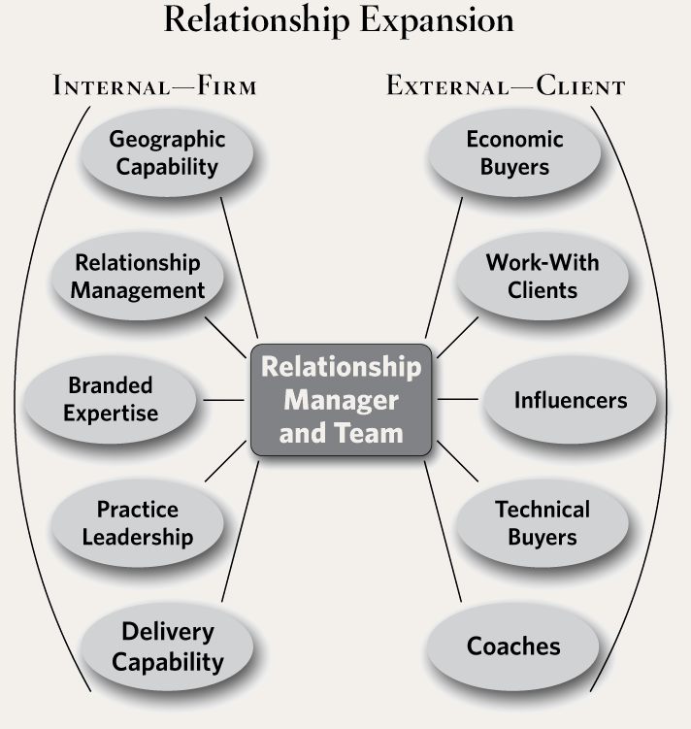

- Callum asks Nadia to put together a list of client relationships that are not working for TTR. He tells Nadia that after discussing them, he will expect Nadia to terminate any existing contracts that are not profitable to the business.

Give a full explanation of the four steps typically found in a successful exit strategy.
(8 marks)

Award 1 mark for successfully naming each of four steps:

A Have a conversation (1 mark)
B Fulfil your project and contract obligations (1 mark)
C Keep it professional (1 mark)
D Conduct an internal post-mortem (1 mark)

Award a further 1 mark for a relevant explanation of each step.

AA Keep communication open. Stay calm and professional. Explain why you are (1 mark)
ending the relationship
BB Provide the client with a handover and deliverables for a mutually agreeable length (1 mark)
of time. Leave on good terms
CC Keep a level head, even if emotions are running high. If the client is upset or angry, (1 mark)
try and disengage. Ask to re-group later, when things have calmed down. If this isn’t
possible, ask a third party for help
DD It is important to understand where the relationship went wrong. After the (1 mark)
relationship has ended, look at what did and didn’t work. What could be done
differently?

(AC: 2.5)

3. Nicki is the Head of Internal Recruitment for a television network. Part of Nicki’s strategic plan for the forthcoming year is to scope out the potential implementation of an appropriate resourcing model. The network is diverse, there are lots of departments and Nicki finds that she will need to manage multiple stakeholders.

- In her ‘mindtools’ study, Rachel Thompson suggests three steps that should be taken to ensure that stakeholders are managed appropriately.

Describe each of these three steps. (9 marks)

Award up to 3 marks for each stage, up to a total of nine marks:

A Plan your approach to stakeholder management (3 marks)
This includes the amount of time allocated to managing stakeholders at each level
and the help each stakeholder could potentially offer

B Think through what you want from each stakeholder (3 marks)
Think of the levels of support needed from each stakeholder and the roles you would
like them to play (if any). List this information down in “desired support”,
“directed project role” and “actions desired” columns

C Identify actions and communications
Identify what needs to be done to reach completion and the time and resources (3 marks)
available. How will communication and input from stakeholders be managed? Think
how to keep the best supporters engaged and on-board. Make stakeholders aware as
early as possible if difficulties arise, so damage is limited

(AC: 3.1)

b) Give two reasons why it might be useful for Nicki to use an influence map.
(2 marks)

Award 1 mark, for up to two of the following:

A Influence mapping is a project management tool that can be used to identify (1 mark)
stakeholders involved in a project and the influence they potentially hold
B Whilst some stakeholders are obvious, others are won’t be as apparent (1 mark)
C Using this tool can ensure the project gains momentum and the message is not (1 mark)
lost on a stakeholder who may not be relevant

R Any other reasonable answer (1 mark)

(AC: 3.1)

- Nicki knows that to keep continued support, she will need to undertake regular stakeholder consultations.

Give two benefits of a stakeholder consultation.
(2 marks)

Award 1 mark for up to two of the following:

A Identify and track needs and expectations (1 mark)
B Identify and track perceptions and attitudes (1 mark)
C Provide feedback on specific planned developments (1 mark)
D Evaluate implementation and actions (1 mark)
E Establish the brand values and positioning of the corporate, as seen by others (1 mark)

R Any other reasonable answer (1 mark)

(AC: 3.3)

(Total: 70 marks)

END OF QUESTIONS

